DEFAULT: Counter is placed on the swimmer's right as they face the turn end of the pool. Default count will be up (1, 3, 5, . . .) unless the swimmer requests down (29, 27, 25, . . .)

Please let us know if you would like the counter placed on the left side facing the pool or count to be down.

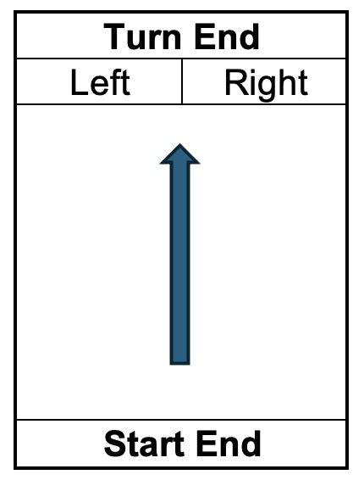

[This signage can be used by the administrative referee when collecting the swimmer’s preference for counter placement and count direction for distance events. It can be customized as needed depending upon the protocol used for the meet. Delete these instructions prior to use.]

